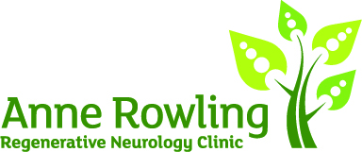

Suggested wording for JustGiving

The Anne Rowling Clinic offers patients a supportive and welcoming space that merges NHS clinical visits with state-of-the-art research. We aim to improve the lives of people with neurodegenerative conditions including multiple sclerosis (MS), motor neurone disease (MND), Parkinson’s disease and early-onset dementias.
The Clinic gives people living with these conditions in Scotland the opportunity to take part in research studies and so be part of innovations and discoveries that will have a positive impact for the future. Alongside research studies conceived and developed here at the Clinic, we contribute to national and international research projects. We’re part of the global effort towards new discoveries, with the ultimate goal of discovering treatments and cures.
Sadly J.K. Rowling’s mother Anne was diagnosed with multiple sclerosis in the early 1980s when no treatment existed. She passed away at the young age of 45. When J.K. Rowling herself turned 45 years old, she made a donation to the University of Edinburgh, enabling the Anne Rowling Regenerative Neurology Clinic to be founded in 2010.

[Insert information about your event here]
The money received through this JustGiving page will go directly to the Anne Rowling Clinic. Please donate generously today and help the researchers achieve their goal of discovering treatments and cures for these devastating conditions.
Thank you for your support.

